Title Using Time New Roman 16 Bold, Should be Simple, and Represent the Article Content

Author-1,¹ author-2,¹ author-3,² and author-4²* (Name of all author using time new roman size 10)

¹Institutional address of author-1 and author-2, using time new roman size 10
²Institutional address of author-3 and author-4 using time new roman size 10, plus email contact address for author marking with star or correspondence author

*Corresponding email : author-4@xxxxmail.com
Email author 1: author_1@xxxxxmail.com
Email author 2: author_2@xxxxxmail.com
Email author 3: author_3@xxxxxmail.com
Email author 4: author_4@xxxxxmail.com

Received day month year; Accepted day month year (will be given)

ABSTRACT

Abstract should be written with time new roman 10 in single space. Justify paragraph and margin with indentation both left and right is 1.5 cm. It contains a brief description of research objective, method and research result. In total words must less than 200 words.

Key word: include 5-6 key words

INTRODUCTION
Body paragraph is written using Time New Roman 12 in single space. Each new paragraph indents in 1 cm. Content of introduction usually the background of research, position of the research toward the other similar research. It can be a brief literature review. Reference cited using endnote style and using arabic number in order from [1], [2], [3] etc. until the last reference.

EXPERIMENT
Chemicals and instrumentation
Chemicals used for research should contain description brand or manufacturer for example: ethyl acetate (Merck), dioctyloxalate (Sigma). To make it consistent, we prefer mention the chemicals in word rather that chemical formula. Meanwhile, sample of research such as plant, animal or microorganism should declare the origin of the sample or method to prepare it.
Instrumentation applied for analysis should be written all tools are used during research. They can contain instrumentation specification or operational conditions include brand manufacturer. For example: FTIR spectrophotometer (Shimadzu FTIR QP89500, sample was analyzed using NaCl plate or thin film).

Procedure reaction
All procedure experiment to obtain research data must be described clearly. For example: Sodium hydroxide (10 mg, 0.25 μmol) in a 25 mL of round-bottom flask was added water (10 mL) and ethyl bromide (xx mg, xx mmol). This mixture was stirred for 30 min and cooled to 0 ºC. etc.

RESULT AND DISCUSSION
Sub-chapter
All result must be describe in a very simple, easily figure out and in high quality resolution. Please put all pictures in the bottom of the article and give a clear label or legend. All figure, table, picture, or reaction schemes are prepared as image file.

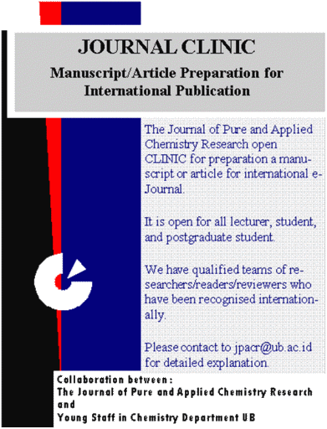

Figure 1. Legend should be written in bold and place below the figure or scheme.

Table 1. Legend should be written in bold and place above the table content, one space. Apply the line only for top and bottom side.

No | AAA | BBB
1 | Aa | BB
2 | AA | BB
3 | AA | BB
4 | AA | BB

CONCLUSION
Conclusion should clearly state the result of correlated objective (and may also possible with future direction). Avoid using point or numbering.

ACKNOWLEDGMENT (if any)
Acknowledgment can be people or institution who gives fund, people who help in technical, suggestion etc.

REFERENCES (All cited references must be listed in this section. To be accepted for publication, we are highly recommended for the submitted manuscript to have minimum 5-10 journal articles. No maximum number of references)
[1] All references must be written using arabic number in order
[2] Format for journal article: all authors, Journal Name in abbreviation (if available) and in italic, Year (in bold), volume (number, if available), page.
[3] Format for books: Authors, Book title, Edition, Year in Bold, Volume (if available), Book publisher, City of Publisher.
[4] Format for Chapter in book: authors, title of chapter, in book author/editor, book title, edition, year (in Bold), publisher, city publisher
[5] Format for unpublished research result such as Skripsi/Thesis/Dissertation: Author, Title of skripsi/thesis/dissertation, Name of institution/department/faculty, name university/institute, country institution, Year (bold).
[6] Format for sources taken from internet: Author or editor, Title of article, URL or homepage address, date of access.
Writting the bibliography or list of references
If you keen using bibliography management software such as Zotero, Mendeley, and Endnote, the reference style can be downloaded from https://www.zotero.org/styles/the-journal-of-pure-and-applied-chemistry-research

